


PROJECT REPORT
Assessment of the impact of essential economic factors on the poverty level in Kazakhstan

Prepared by:
Aruana Sadubayeva,Arlan Toktarkhan,Arys Alpys,Ilyas Okenov
Information systems in business
Submitted to:
Alisher Aldashev

Almaty, 2024-2025

EXECUTIVE SUMMARY
This study focuses on understanding how economic factors affect poverty in different regions of Kazakhstan from 2011 to 2024.The variables used in the analysis are real GRP per capita,unemployment rate,real capital investment,inflation and average wages.Moreover,fixed and random effects models were applied to estimate the contribution of these factors to poverty.The main findings of our study are that real GRP and capital investment have a positive impact on poverty reduction, while unemployment and inflation have a negative impact on poverty reduction
In order to check the reliability of the results, several analyses were carried out and we concluded that the model excluding new regions and large cities showed the least skewed results. This analysis emphasizes the importance of developing economic policies that focus on increasing capital investment, reducing unemployment, controlling inflation and addressing inequality between regions

TABLES OF CONTENTS
INTRODUCTION 4
LITERATURE REVIEW: 5
DATA 6
RESULTS 8
CONCLUSION 27
REFERENCES: 28

INTRODUCTION
The influence of economic factors significantly affects the socio-economic situation in the country. This is actually a driving force that can transform the economy of the regions. In Kazakhstan, the difference in living standards between regions, including poverty rates, remains a rather acute problem. In order to combat poverty and ensure sustainable development, we decided to conduct a study on how exactly economic factors affect the situation in each region of Kazakhstan. Why did we find this topic interesting?
Firstly, understanding how various economic factors such as average wages, inflation, capital investment, unemployment rate and GRP per capita affect the level of poverty is a source of effective economic and political strategies that can significantly improve the lives of the population. Secondly, poverty issues are relevant for any country, especially in developing countries such as Kazakhstan, where economic growth and social development do not always go hand in hand. This topic helps us understand what measures are most effective in combating poverty and what tools will be most effective in improving the well-being of citizens. Thirdly, the purpose of this study is based on the application of econometric analysis, which makes the topic even more interesting and important, since this analysis helps to identify specific relationships and accurately understand which factors have the greatest impact on the standard of living.

LITERATURE REVIEW:
The problem of poverty and its relationship with various economic factors is a very important topic for research not only in academic circles, but also in political debates. Such variables as average wages, unemployment rate, inflation, capital investment and GRP per capita and their relationship with the poverty level attract researchers around the world. Now we rely on different opinions and conclusions of researchers, we want to consider how the above factors affect poverty in Kazakhstan. According to the analysis of many works, an increase in the average salary directly affects the reduction of the poverty level. In large cities of Kazakhstan, such as Astana and Almaty, wages are higher than in rural areas, while the poverty level is noticeably lower. According to The World Bank (2020), improvements in living standards are associated with an increase in average wages, since a higher income level allows people to purchase higher quality goods and services. Today, the lack of stable income causes financial difficulties for people, which indicates a connection between the level of unemployment and poverty of the population. Dabla-Norris et al. (2015) stated that in the long run, unemployment increases poverty, since people are deprived of the opportunity to earn money, thereby cannot improve their situation. This suggests that it is very important to create new jobs in order to reduce the poverty level. In addition, capital investment plays a significant role in economic growth, which is also a source of poverty reduction. Aizenman and Marion (2010) argued that sustainable economic development and poverty reduction depend on capital investment, as they contribute to the creation of new jobs and the development of infrastructure. As for inflation, its growth leads to a decrease in purchasing power, in particular among the poor. Researchers write that “Inflation can intensify poverty by eroding the purchasing power of low-income individuals and families, making essential goods and services less affordable” (Dabla-Norris et al., 2015). This emphasizes the importance of inflation in order to avoid deterioration in living conditions. Finally, one of the directly important factors that influence the poverty level is GRP. It is known that regions with higher GRP rates reduce poverty. The study by Andhykha et al. (2018) states that unemployment and GRP have a significant positive effect on poverty. While Wijaksana (2022) concludes that GRP does not have much impact on poverty. Studying the impact of these macroeconomic factors will help us identify the factors that influence poverty reduction and then develop effective comprehensive approaches to address this problem.

DATA
Data for this study were taken from the Bureau of National Statistics of the Agency for Strategic Planning and Reforms of the Republic of Kazakhstan. Interregional quarterly data for the period from the 1st quarter of 2011 to the 3rd quarter of 2024 were used for the analysis covering the whole country. However, oblasts such as Abay, Zhetysu and Ulytau do not have observations earlier than 2022, as they were formed in the middle of this year. Also, data for the city of Shymkent became available only from 2018 due to its designation as a city of republican significance. Therefore, the panel data for the regions are unbalanced.
With regard to the methodology for calculating the variables, 2011 was the starting point of the observation period. The poverty rate is estimated by the concept of absolute poverty, which defines the number of people with incomes below the subsistence minimum as a percentage of the total population. The unemployment rate is determined by a sample employment survey, where an individual who is searching for a job and is ready to start working is unemployed. The proportion of unemployed peoples is calculated relative to the population in a given region, measured in percentages. Average wage is a nominal indicator in tenge that is calculated by observations of all legal entities and structural subdivisions, except for small enterprises engaged in entrepreneurship, of all types of economic activity. Investment in fixed capital characterises investments in new construction and reconstruction of facilities for economic, social or environmental benefit to investors. Inflation is calculated using a fixed list of goods and services purchased by the population for personal use. Gross Regional Product (GRP) per capita is a share of the total GDP of the country for a given region. It was calculated by the ratio of all goods and services produced within the region and the current population.
To remove the influence of unobserved but time-constant factors specific to each region (such as geographical location, climate, infrastructure), a fixed-effects model is applied. This allows us to obtain estimates of the impact of economic variables on poverty, taking into account within-group variation. This model is obtained by regressing time-demeaned data on dependent variable on time-demeaned predictors:
${\ddot{y}}_{it}={β_{1}\ddot{x}}_{it1}+{β_{2}\ddot{x}}_{it2}+...+{β_{k}\ddot{x}}_{itk}+{\ddot{u}}_{it}$,
where ${\ddot{y}}_{it}= y_{it}-{\overline{y}}_{i}$ (${\overline{y}}_{i}$ is the individual mean of the region $i$), ${\ddot{x}}_{it}$ and ${\ddot{u}}_{it}$ are defined similarly.
To prove that the choice of fixed effect model is correct, a simple random effects model was constructed and then tests were conducted to identify the statistical significance of individual qualities of individual regions using the Hausman test to identify whether there is correlation between individual-specific factors that are eliminated in fixed effect model and independent variables. The null hypothesis of no correlation is rejected at extremely low significance level, thus there is statistical evidence that random effects model gives biased coefficients and fixed effects model should be used.
It is important to check that no perfect linear relationships exist among the explanatory variables. Thanks to the variance inflation factor (VIF) of each individual coefficients, the problem of perfect multicollinearity are exposed to be not feasible. The formula of the VIF for variable $x_{j}$ is: ${VIF}_{j}=1/(1-R_{j})$, where $R_{j}$ is correlation between variable $x_{j}$ and all other regressors.
The fixed effects model relies on the assumption of strict exogeneity. That means any shocks in poverty rate in a given region which are not explained by the level of investment, inflation, or other regressors are uncorrelated with those variables across all time periods. The point to reduce the risk of violation is to find that potential variables which might have not contemporaneous, but lag effect on dependent variables, which is, in this study, investment in fixed assets since spurious correlation driven by reverse causality in the model could lead to bias results.
When the model was tested for efficiency, the autocorrelation was statistically confirmed by the Wooldridge serial correlation test, rejecting the null hypothesis of no first-order serial correlation between time periods. The solution to minimize the consequence of invalid test statistics is to use robust standard errors, such as Driscoll-Kraay standard errors.(reference) It is also useful for dealing with heteroskedasticity in idiosyncratic errors, which give more efficient coefficients.

RESULTS
This part of our study provides the results of our regression analysis using panel data to identify how key economic variables, such as real GRP per capita, unemployment rate, real capital investment, inflation, and average wages, affect the poverty rate in different regions on a quarterly basis from 2011 to 2024.
Two different models with panel data were used for this purpose: Fixed effects and Random effects models.
In Kazakhstan, some regions such as Abay, Ulytau, Zhetisu, Turkestan, and the city of Shymkent are new, and data for these regions are not available earlier than 2018. In order to get more accurate results, we used four different analyses. In the first one, we removed these regions completely and built models from 2011 to 2024. In the second one, we built models before 2018, and in the third one, we built models after the appearance of these regions, i.e., from 2018 to 2024. And finally, analysis without Almaty and Astana.
We used 20 regions and 55 quarters in this analysis.
- Analysis without regions with incomplete data
1.1 Fixed effects model
Our first model is Fixed effects model, which manages unobserved characteristics of a given region. This approach provides more accurate results by taking into account the specific factors of each region.
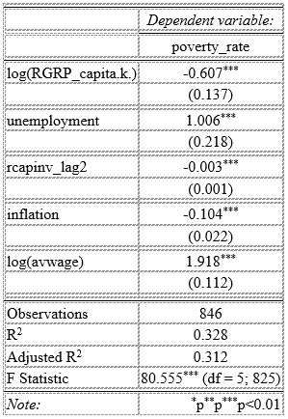
As we can see, this model is statistically significant since the F-statistics = 80.555 and p-value<2.2e-16. R-squared is 0.328, which explains about 32.8% of the variation in poverty rate through the included variables. This is a moderate fit, demonstrating that the model considers some key correlations, but there are still unexplained variations that are not included in the model.
In our model, all five explanatory variables are statistically significant at the 0.1% or lower significance level, indicating strong evidence that they all contribute to explaining changes in the poverty rate.

1.2 Random Effects Model
The Random Effects Model assumes that region-specific effects are random and uncorrelated with the independent variables. The findings are as follows:
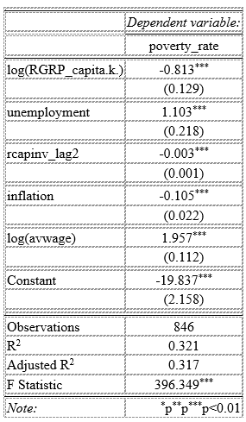
Overall, because of high Chisq: 286.306 and extremely low p-value, it can be stated that this model is significant. In addition, all 5 independent variables are also statistically significant at a 0.1% significance level, due to very low p-values.
R-squared is 0.24797, indicating that our independent variables explain about 24.797% of the variation in the poverty rate. The model needs some additional independent variables.

1.3 Model Specification Tests
We conducted several specification tests to assess the choice of models and investigate the presence of autocorrelation in this analysis.
- Hausman Test
The Hausman specification test was performed to determine whether the Fixed effects model or the Random Effects model is more appropriate for this analysis.
Null hypothesis: The Random Effects model is preferred
Alternative: The Fixed Effects model is preferred

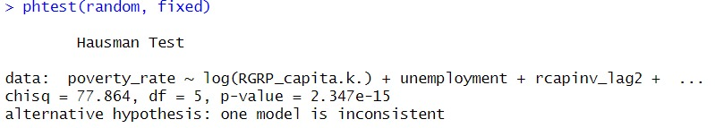
Since the p-value is less than all common significance levels, we can reject null hypothesis. There is enough statistical evidence that the Fixed Effects model is preferred than the Random.
- Wooldridge Test
We applied the Wooldridge test, to test for autocorrelation in the panel data.
Null hypothesis: No autocorrelation
Alternative hypothesis: There is autocorrelation
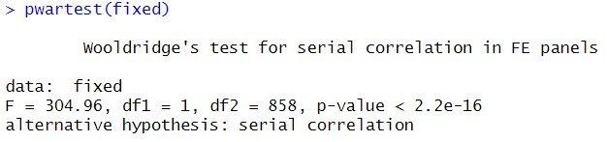
P-value < 2.2e-16, which means we reject the null hypothesis. We have enough statistical evidence that there is autocorrelation.

1.4 Improving our model
After specification tests, we found that we need to use the Fixed Effects model and have the problem of autocorrelation in this model. In order to ensure accurate statistical inference, we applied a new Fixed Effects model with Driscoll-Kraay standard errors, which are robust to autocorrelation within panels. By using this method, we generated more reliable standard errors and p-values for coefficients.
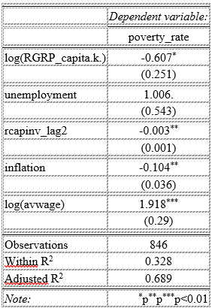
These regression results with Driscoll-Kraay standard errors show that the association between our independent variables and poverty rate is still statistically significant even after controlling for autocorrelation and heteroskedasticity. This increases the robustness of our findings. Let us now proceed to the interpretation of the final model:
Log (Real GRP_capita.k.): Within a given region, by holding other variables constant, a 1 percent increase in Real GRP per capita from one quarter to another decreases the poverty rate by –0.607 percentage point on average. P-value of 1.9357e-02 indicates that the estimated slope is statistically significant at a 5% significance level.
Unemployment: A 1 percentage point increase in the unemployment rate from one quarter to another is associated with an increase of 1.006 percentage points in the poverty rate within a specific region and controlling for other variables. The estimated coefficient is statistically significant at a 10% significance level.
Real Capinv_lag2: The coefficient for the Real Capital investment per capita (in thousands of tenge) with two-quarter lag is -0.0033 (p-value 2.0887e-03). This indicates that within a given region, if we hold other variables constant, a 1000 tenge increase in Real Capital investment per capita in the two quarters ago decreases the Poverty Rate by 0.0033 in the current quarter on average. This coefficient is statistically significant at a 1% significance level.
Inflation: Holding ceteris paribus, within individual regions, if the inflation rate increases by 1 percentage point, the poverty rate will decrease by 0.104 percentage points on average. Even though it might seem counterintuitive, this coefficient is statistically significant at a 1% significance level.
Log (Avwage): Controlling for other variables, a 1 percent increase in average wage increases poverty rate by 1.918 percentage points on average. Although it also sounds contradictory, from a statistical perspective, it has significance, since the p-value is extremely small. This could be due to inequalities between different regions.
The R-squared is 0.328, which indicates that 32.8% of the variation in the poverty rate across regions and quarters is explained by the real GRP per capita, unemployment, real capital investment, inflation, and average wage.

2) Analysis before 2018
2.1 Fixed Effects Model
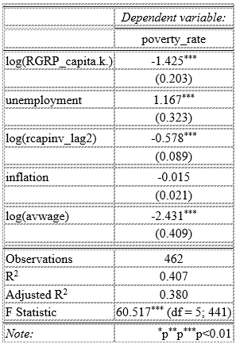
The fixed effects model shows substantial overall significance with an F-statistic of 60.5168 (p-value < 2.2e-16).
The R-squared of the model is 0.40693. It indicates that the included predictors account for approximately 40.7% of the within-region variability in the poverty rate. This suggests a good fit for panel data, however, certain unobserved factors may still influence the poverty rate.
Four of the five explanatory variables are statistically significant at the 0.1% significance level. Only inflation does not appear to have a statistically significant impact on the poverty rate.
2.2 Random Effects Model
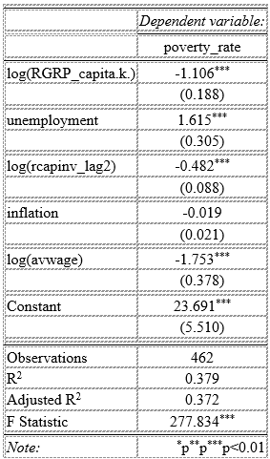
The Random Effects Model also performs well, with a Chi-squared statistic of 277.83 and p-value < 2.2e-16, indicating overall significance.
The R-squared is 0.3787, which is slightly lower than in the Fixed Effects Model, indicating a marginally worse fit.
Nonetheless, the key findings are consistent: the same four out of five variables are highly significant due to low p-values. Inflation is again not significant.

2.3 Model Specification Tests

- Hausman Test
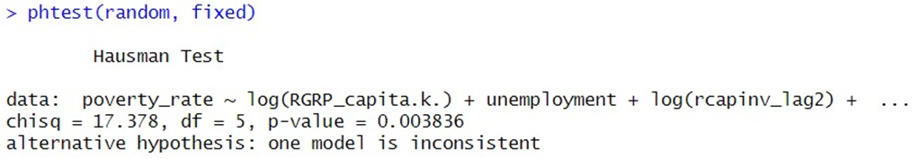
The Hausman Test shows us that the Fixed Effects Model is preferable to Random at a 1% significance level.
- Wooldridge Test
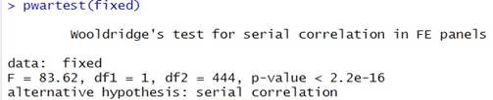
This test shows that there is a problem of autocorrelation between panels.

2.4 Improving our model
As in the previous analysis, we use a new fixed effects model with Driscoll-Kraay standard errors.
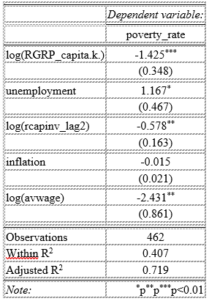
Interpretation of the results of the final model:
Log (Real GRP_capita.k.): The coefficient for the natural logarithm of Real GRP per capita in thousands of tenge is -0.348 (p-value 0.0003). It implies that by keeping other variables constant, within a specific region, a 1 percent increase from one quarter to another in GRP per capita decreases the Poverty Rate by 1.425 percentage points on average. This coefficient is statistically significant at 0.1% significance level.
Unemployment: The coefficient for unemployment is 1.1674 (p-value 0.0187). It indicates that by holding other variables constant, within a specific region, a 1 percentage point increase from one quarter to another in the unemployment rate increases the Poverty Rate by 1.1674 percentage points on average. This estimated slope is significant at the 5% significance level.
Log (Real Capinv_lag2): The estimated coefficient for the Real Capital Investment per capita (in thousands of tenge), lagged by two quarters, is -0.578 (p-value 0.0014). It shows that on average, a 1 percent increase in the two quarters earlier is associated with a decrease of 0.578 percentage points in the current quarter’s poverty rate, within a specific region, by holding ceteris paribus. This coefficient is statistically significant at a 1% significance level.
Inflation: The estimated coefficient for the Inflation rate is -0.0154 (p-value 0.4776). Despite the negative relationship, we cannot say that investment influences poverty, because of the high p-value.
Log (Avwage): For the Average wage, the slope is -2.431 (p-value 0.0087). This coefficient is also statistically significant at all common significance levels. Compared with the previous analysis, there is a more logical relationship between wages and poverty. Higher average wages are associated with lower poverty rates.
Our R-squared is 0.407, which means that 40.7% of the within-region variation in the poverty rate over time is explained by our independent variables. It is a moderate fit, which means this model is useful, however, we need additional independent variables to get a higher R-squared.

3) Analysis after 2018
Now let’s move on to parsing the models built from data after 2018, once the new regions have been added.
3.1 Fixed Effects Model
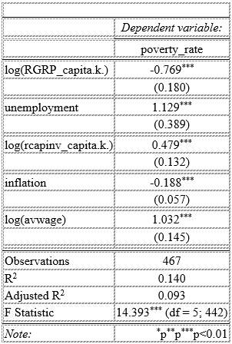
Let us turn to the results of the Fixed Effects Model:
As we can see, overall, our model is statistically significant due to the low p-value. This shows that at least one independent variable is not equal to zero and has an impact on the poverty rate.
In addition, all explanatory variables are highly significant due to the fact that all p-values are below 0.001. This means that they are significant at the significance level of 0.1%.
The R-squared is 0.14. It indicates that 14% of all variations in the poverty rate is explained by the independent variables. While this value may seem low, it is typical for panel data models that focus on within-region variation. Moreover, our estimated coefficients are statistically significant, so the model still provides meaningful insights.

3.2 Random Effects Model
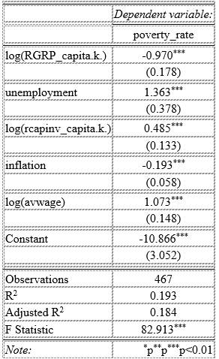
Random Effects Model also provides significant results with extremely low p-value. R-squared is larger in this model, and all explanatory variables are also significant at a 0.01% significance level.

3.3 Model Specification Tests
In this part, we perform the same tests as in the previous analyses to check which model is better and to check for the autocorrelation problem.
- Hausman Test
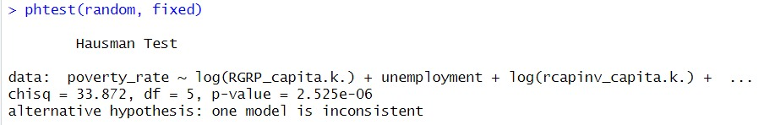 Based on these results, we can see that the Fixed Effects Model is more desirable. (p-value = 2.525e-06)

- Wooldridge Test
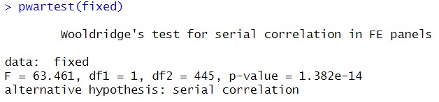
According to these outcomes, it is clear that our model has an autocorrelation problem, because the p-value is too small, 1.382e-14.

3.4 Improving our model
To improve our Fixed effects model, we do the same thing we did before, simply introduce a new Fixed effects model with Driscoll-Kraay standard error. The results are as follows:
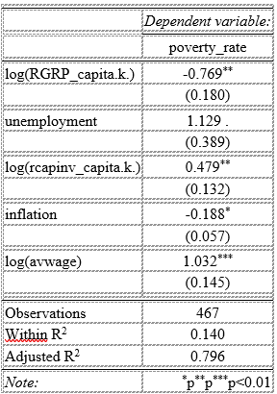
Log (Real GRP_capita.k.): Within a given region, if real GRP per capita (in thousands of tenge) increases by 1 percent compared to the previous quarter, then the poverty rate will decrease by -0.7686 percentage points on average, by holding other variables constant. This coefficient is statistically significant at all common significance levels. (1%, 5%, 10%)
Unemployment: Within a specific region, assuming ceteris paribus on other variables, by increasing unemployment by 1 percentage point from one quarter to another, we will increase the poverty rate by 1.1291 percentage points on average. This coefficient is statistically significant at a 10% significance level.
Log (Real capinv_capita.k.): If real capital investment per capita (in thousands of tenge) in a region rises by 1 percent relative to previous values, the poverty rate in the same region rises by 0.4787 percentage point on average, holding other variables constant. The estimated coefficient is significant at 0.1% due to the low p-value.
Inflation: The estimated coefficient for inflation is -0.1875 with a p-value of 1.3221e-02. The negative relationship between inflation and poverty rate may seem unexpected, but it is a statistically significant result at a 5% significance level.
Log (avwage): A 1 percent rise in regional average wages over time is associated with a 1.03 percentage points increase in poverty rate, which is also counterintuitive. However, this coefficient is statistically significant at 0.1%.
An R-squared value is 0.14, which is the same as in the Fixed Effects Model.

4) Analysis without Almaty and Astana
In this part we analyse the models without considering the regions of Almaty and Astana, as these cities differ significantly from other regions of Kazakhstan with their specific economic and social characteristics. In addition, we do not include the new regions and the city of Shymkent, as they will affect the regions from which they split off. This will allow us to more accurately assess the impact of our explanatory variables on poverty among typical regions of Kazakhstan.

4.1 Fixed Effects Model
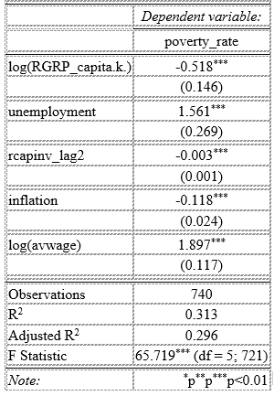
The fixed effects model shows weighty overall significance with an F-statistic of 65.719 (p-value < 2.0527e-08). The R-square is 0.313, so about 31.3% of the variation is explained by the poverty level with the included variables. This indicates a reasonable fit, implying that although the model explains a significant percentage of the variation, there remain unaccounted factors affecting the poverty rate. The estimated coefficients are statistically significant at the 0.1% level for all variables except log(RGRP_capita.k.).

4.2 Random Effects Model
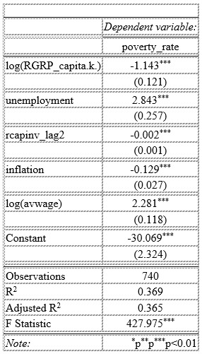

The Random Effects Model shows strong results with an F-statistic of 427.975 and a very low p-value (< 2.2e-16), proving that the model is significant. The R-squared value of 0.369 is higher than the Fixed Effects Model, meaning it explains 36.9% of the changes in the poverty rate. While this is a good fit, it suggests that there are still some factors affecting poverty that the model does not capture.
All the variables in the model are statistically significant at the 0.01% level, showing that they all play an important role in explaining changes in the poverty rate.
4.3 Model Specification Test
1) Hausman Test
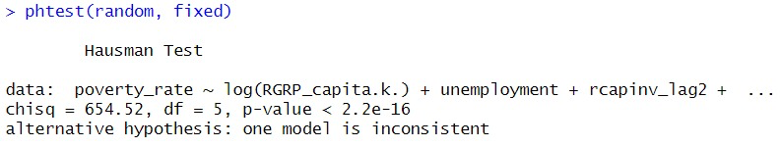
Based on these results, we can see that the Fixed Effects Model is more preferable, with a p-value < 2.2e-16, indicating strong statistical significance.

4.4 Improving our model
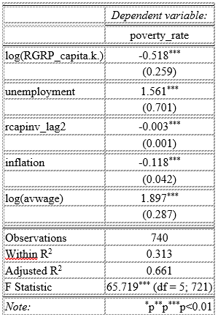
Log (Real GRP_capita.k.): Within a given region, if real GRP per capita (in thousands of tenge) increases by 1 percentage point compared to the previous quarter, then the poverty rate will decrease by 0.5182% on average, holding other variables constant. This coefficient is statistically significant at all common significance levels (1%, 5%, 10%).
Unemployment: Within a specific region, assuming other variables remain constant, a 1 percentage point increase in unemployment will result in a 1.5612% increase in the poverty rate on average. This coefficient is statistically significant at the 5% significance level.
Log (Real capinv_capita.k.): If real capital investment per capita (in thousands of tenge) increases by 1 percentage point compared to previous values, the poverty rate will rise by 0.0031% on average, holding other variables constant. This coefficient is statistically significant at the 1% significance level due to a low p-value.
Inflation: The estimated coefficient for inflation is -0.1184, with a p-value of 6.9383e-03, indicating a negative relationship with the poverty rate. This is statistically significant at the 5% significance level.
Log (avwage): A 1% increase in regional average wages over time is associated with a 1.8969% increase in the poverty rate on average. This coefficient is statistically significant at the 0.1% significance level.
The R-squared value is 0.3131, which is the same as in the Fixed Effects Model.

CONCLUSION
The project's conclusion revealed vital findings about poverty response to economic factors in Kazakhstan's regions through regression analysis and Hausman and Wooldridge tests for autocorrelation and model correctness. We conducted four separate cases to validate our research results.
The initial analysis excluded data from new regions including Abay, Ulytau, Zhetisu, Turkistan and Shymkent because no statistical information existed before 2018. We used this approach to calculate the model without data distortion that could result from missing information for these regions. The analysis of data from before 2018 served to determine how the exclusion of future regions impacted the research findings. The third case examined data spanning from 2018 through 2024 which included the new regions to evaluate their influence on the research findings. The fourth case studied typical regions in Kazakhstan by removing both large cities Almaty and Astana together with new regions to evaluate economic factors under normal circumstances.
We determined that the model without Almaty and Astana and new regions (Shymkent) produced the least skewed and most representative results. The fixed effects model had an R-squared value of 0.313 which means that the model explained 31.3 per cent of the poverty rates variation. The R-squared values of the models that included all regions (before and after 2018) were 0.24498 and 0.40693 respectively. The inclusion of incomplete data or large cities with exceptional economic conditions lowers the explanatory power of the model. The exclusion of these regions provided a better estimate of the economic factors that affect poverty.
Our results indicated that GRP per capita and capital investment are positively related to poverty reduction, but unemployment and inflation are negatively related to poverty reduction. However, the relationship between average wages and poverty was not straightforward: higher wages were associated with higher poverty, but this could be due to income inequality between regions. Nevertheless, the relationship remained statistically significant.
The results of the study indicate that economic policy should focus on increasing capital investment, reducing unemployment and inflation to reduce poverty. Creating jobs in underdeveloped regions and combating income inequality between regions would also be an important step. Further refinement of the model with additional factors or expansion of the data will allow for more accurate conclusions and better recommendations.

REFERENCES:
1.Andhykha, R., Handayani, H. R., & Woyanti, N. (2018). Analysis of the Effect of GRDP, Unemployment Rate, and HDI on Poverty Level in Central Java Province. Media Economics and Management. 33(2), 113-123

2.Cembawan Wijaksana, A. (2022). Analysis of the Effect of Gross Regional Product, Human Development Index, and Unemployment Rate on Poverty in Banten Province in 2016-2021. Journal of Management, Business and Accounting

3. Aizenman, J., & Marion, N. P. (2010). Using inflation to erode the US public debt. Journal of Macroeconomics, 32(2), 524-541. https://doi.org/10.1016/j.jmacro.2011.09.001

4. Dabla-Norris, E., Kochhar, K., Suphaphiphat, N., Ricka, F., & Tsounta, E. (2015). Causes and consequences of income inequality: A global perspective. Washington, D. C.: International Monetary Fund. https://doi.org/10.5089/9781513555188.006

5. Seitz, W. (2018). Urbanization in Kazakhstan: Desirable cities, unaffordable housing, and the missing rental market(Policy Research Working Paper No. 8530). World Bank. https://openknowledge.worldbank.org/handle/10986/30289

